|  |  |  |  |  |  |
| --- | --- | --- | --- | --- | --- |
|  | A | |  |  |  |
| B | 0 | 0 | 1 | 1 |  |
| 0 | 0 | 1 | 1 | D |
|  | 1 | 1 | 0 | 0 |
|  | 1 | 1 | 1 | 0 |  |
|  |  | C | |  |  |

|  |  |  |  |  |
| --- | --- | --- | --- | --- |
| A | B | C | D | Y |
| 0 | 0 | 0 | 0 | 0 |
| 0 | 0 | 0 | 1 | 0 |
| 0 | 0 | 1 | 0 | 1 |
| 0 | 1 | 0 | 0 | 1 |
| 1 | 0 | 0 | 0 | 1 |
| 1 | 1 | 0 | 0 | 0 |
| 1 | 0 | 1 | 0 | 1 |
| 1 | 0 | 0 | 1 | 1 |
| 0 | 1 | 1 | 0 | 1 |
| 0 | 1 | 0 | 1 | 1 |
| 0 | 0 | 1 | 1 | 0 |
| 1 | 1 | 1 | 0 | 0 |
| 1 | 1 | 0 | 1 | 0 |
| 1 | 0 | 1 | 1 | 1 |
| 0 | 1 | 1 | 1 | 1 |
| 1 | 1 | 1 | 1 | 0 |

Y = /AB + A/B + C/D/B

Y = A xor B + /B C /D

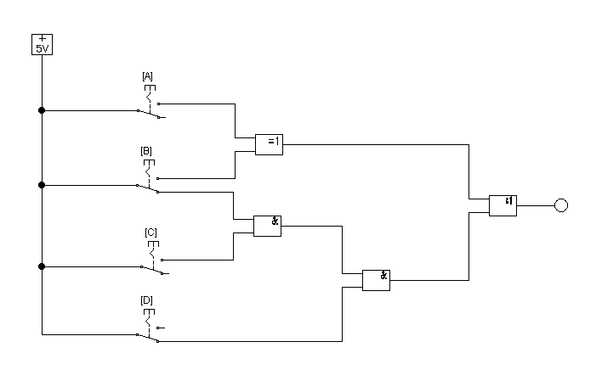

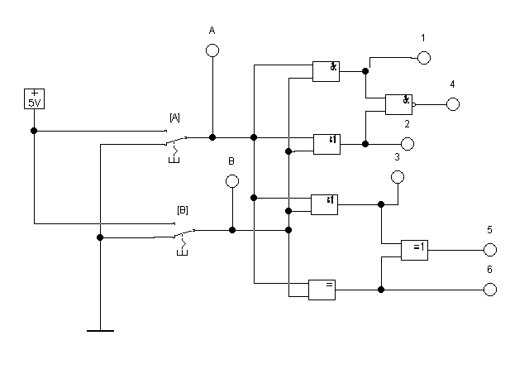

|  |  |  |  |  |  |  |  |
| --- | --- | --- | --- | --- | --- | --- | --- |
| A | B | Y1 | Y2 | Y3 | Y4 | Y5 | Y6 |
| 0 | 0 | 0 | 0 | 0 | 1 | 1 | 1 |
| 0 | 1 | 0 | 1 | 1 | 1 | 1 | 0 |
| 1 | 0 | 0 | 1 | 1 | 1 | 1 | 0 |
| 1 | 1 | 1 | 1 | 1 | 0 | 0 | 1 |

Y1 = AB

Y2 = Y3 = A+B

Y4 = Y5

Y6 = /(AxorB)

